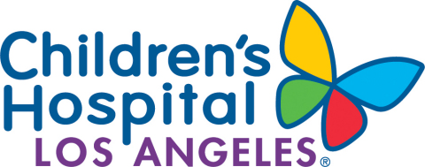

Release of Information FAQs

- Q: How do I submit my request?
A: You may visit our Family Resource Center at CHLA (address can be found on the attached authorization), a representative will provide the authorization form and guidance on how properly fill it out. You will be asked to provide a government issued identification to confirm identity. You may also choose to mail in your request along with a copy of government ID to the address on the form. Email option is also available, please scan and email your request (and ID) to our himrequest@chla.usc.edu email.
- Q: What are your hours of operation?
A: Monday-Friday 8:00a.m.- 4:00p.m.
- Q: Do you charge for medical records?
A: If the records are for the patient/guardian and or for continuation of treatment, we do not charge. Fees may apply for other purposes.
- Q: How long does it take to get my records?
A: We have 15 days to process and complete a request from the day it was submitted. If the record contains any confidential information the request may take longer to process, detailed correspondence will be mailed out to the requesting party.
- Q: What if I need my records sooner than 15 days?
A: Requests may be expedited based on reason; it is up to the discretion of the HIM Manager to expedite the request.
- Q: What would be included in the “clinically relevant pertinent information?”
A: Clinically relevant pertinent information includes, if available, history and physical reports, operative report, discharge summary, consults and referrals, outpatient provider notes, laboratory results, pathology reports, and radiology reports for the last 2 years of visits.

If you have any questions regarding the completion and submission of this authorization, please call 323-361-2381 and a member of the Health Information Management Team will provide assistance.

