**Note: All instructions are in red. Please modify the form for use with a specific protocol and remove all instructions/red text (including those in the footer) before use with subjects. Please ensure that the text remains in 14 pt. font to comply with regulatory requirements.**

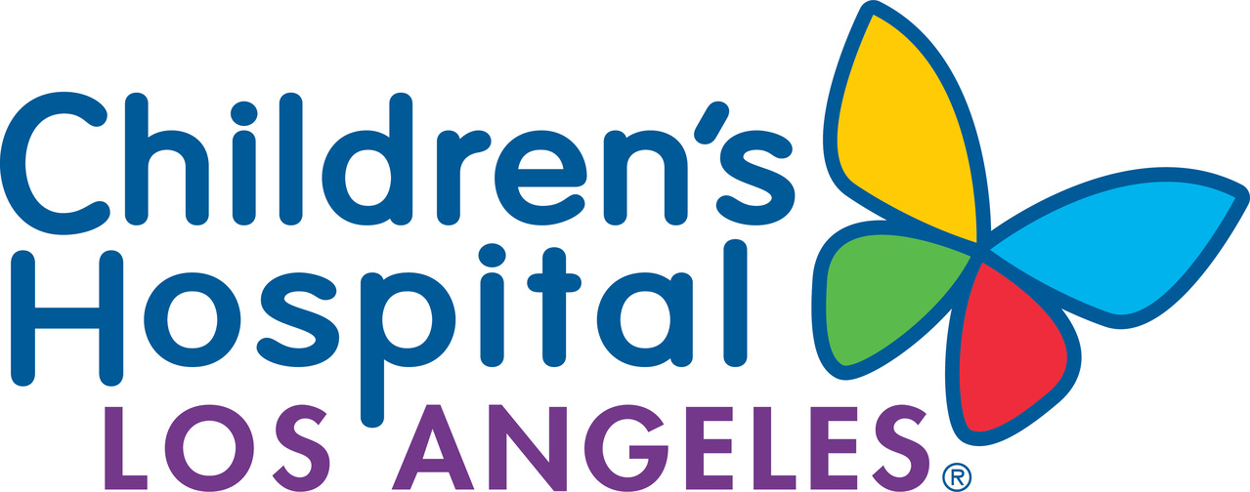

AUTHORIZATION FORM

PERMISSION FOR USE AND/OR DISCLOSURE OF PROTECTED HEALTH
INFORMATION FOR RESEARCH PURPOSES

PRINCIPAL INVESTIGATOR (Individual in charge of the research team at CHLA): [PI of protocol]

Study Title (or IRB Approval Number if study title may breach Participant's privacy): [add study title or IRB number as applicable]

What is the purpose of this form?
State and federal privacy laws protect the use and release of your health information. Under these laws, CHLA or your health care provider cannot use or disclose your protected health information for research purposes without your permission unless a regulatory exception applies. This form describes the different ways that we can share your information with the research team, sponsors/collaborators, and people with oversight responsibility.

Patient/Subject Name:

Medical Record Number: Date of Birth:

BACKGROUND and DEFINITIONS

HIPAA stands for the Health Insurance Portability and Accountability Act. HIPAA contains federal regulations that govern the privacy and confidentiality of medical information maintained by healthcare providers. Participants in research studies are protected by HIPAA regulations. Information used in research studies may include data that identifies you. When you decide to take part in a research study, you must give permission for your protected health information to be released from the research team at Children’s Hospital Los Angeles and your doctors to the outside researchers involved in conducting the research study.

Protected health information is personal information that can identify you or that can be linked to you. Examples of protected health information include personal information such as your date of birth or where you live and information about your medical condition. Only you or your legal representative can give permission for your protected health information to be released.

By agreeing to sign this authorization form, you are allowing researchers at Children’s Hospital Los Angeles to collect your protected health information and share it with others involved in doing this research study as detailed below, consistent with California and Federal laws concerning the privacy of this information.

RESEARCH STUDY INFORMATION

The protected health information that is needed for this research study includes: (Please describe, examples are provided below. Please modify, add, and/or remove types of data to only include what is relevant to your study protocol.)
- Personal demographic information;
- History and diagnosis of your medical condition;
- Specific information about the treatments you will receive or have received, including treatment(s) you may have had in the past;
- Information about other medical conditions that may affect your treatment;
- Medical data including laboratory test results, results of tests measuring organ function (e.g., kidney, heart, lung), results from radiology scans, pathology or other test results;
- Information on treatment and the side-effects you may experience during this research study and how they were treated; and
- Long-term information about your general health status and the status of your medical condition.

(Insert the following initials section only if applicable and remove any examples that are irrelevant to your study protocol.):

The following information will only be released if you give your specific permission by putting your initials on the line(s).

I agree to the release of information pertaining to drug and alcohol abuse, diagnosis or treatment.
I agree to the release of HIV/AIDS testing information.
I agree to the release of genetic testing information.
I agree to the release of information pertaining to mental health diagnosis or treatment.
I agree to the release of psychotherapy notes.
____________________________________________________________

California law prohibits the disclosure of any protected health information not listed in this authorization unless another authorization form is obtained from you or unless such disclosure is specifically required or permitted by law.

In addition, your medical records may need to be reviewed and the researchers may need to discuss your health information with your healthcare providers. This research also may create new information about you as a result of research procedures, tests, questionnaires, interviews, and visits.

The research team at Children’s Hospital Los Angeles [select either] receives [or] does not receive payment for your participation in this research study and subsequent use of your protected health information.

DISCLOSURE OF PROTECTED HEALTH INFORMATION

You give permission for the following persons, groups or organizations to use or disclose (release) your protected health information for the research study described in this authorization form. (Please list only those that apply.)

1. [Name of Researcher] and his/her research staff [always keep in]
2. All health care providers with health information about you [always keep in]
3. The CHLA Institutional Review Board for oversight and compliance purposes [always keep in]
4. Other: [Specify]

RECEIPT OF PROTECTED HEALTH INFORMATION

You give permission for the following persons, groups or organizations to receive your protected health information for the research study described in this authorization form. (Please list only those that apply.)

- The sponsor of the study [Name of the sponsor] or its representatives [(e.g. drug company, foundation, etc…) will have access to coded and/or directly identified data (please specify)]
- The following institutions/investigators that are participating in this research: [Name of collaborating institutions/investigators (i.e., study coordinating center or protocol chair at another institution), and other collaborating researchers/Institutions]
- Federal, State, and foreign [keep “foreign” if this is a multi-site protocol also being conducted outside of the U.S., whether or not CHLA is the coordinating center] agencies that have authority over the research when required by law.
- Our Hospital, its representatives, or other accrediting agencies. [always keep in]
- A data safety board that may be formed to monitor the safety of the research. (leave in if applicable)
- Your health insurer or payer, if necessary, to secure their payment for any covered treatment not paid for by the research. [always keep in]

CONFIDENTIALITY and PRIVACY

Efforts will be made to ensure that your protected health information will not be shared with other persons, groups, or organizations outside of the research study. Those persons who receive your health information may not be required by privacy laws to protect it and may share your information with others without your permission, if permitted by laws governing them. The research team cannot guarantee absolute confidentiality and privacy.

EXPIRATION

This permission to release your Personal Health Information expires when the research ends and all required study monitoring is over. Information that is collected for research purposes continues to be analyzed for many years and it is not possible to determine when it will be complete.

YOUR RIGHTS

You may decide not to sign this authorization form. If you do not sign this authorization form, you will not be able to take part in this research study. Your regular healthcare including treatment, payment or enrollment in any health plans or your eligibility for benefits will not be affected if you decide not to sign.

You may revoke your permission at any time for Children’s Hospital Los Angeles to use or share your protected health information collected for this research study. However, even if you revoke this authorization, the hospital and the research team may still use information about you that was collected as part of the research project (i.e., side-effects related to the research) between the date you signed the current form, and the date you revoked the authorization. This is to protect the quality, integrity and reliability of the research results. Once you revoke your authorization, no further protected health information will be disclosed.

You must revoke your authorization in writing. You may submit a written request to revoke your authorization, or you may request a form for this purpose from the CHLA Human Subjects Protection Program, (323) 361-2265.
This document must be signed by you or on your behalf and delivered to the following address:

[Name of Principal Investigator], Children’s Hospital Los Angeles, 4650 Sunset Boulevard [enter Mail stop #], Los Angeles, California 90027

Your cancellation will be effective upon receipt but will not be effective to the extent that the Children’s Hospital Los Angeles research team or others have acted in reliance upon this Authorization.

You will receive a copy of this Authorization Form.

You have the right to review and/or copy your medical records containing your protected health information kept by Children’s Hospital Los Angeles.

[Include if subjects will not be able to look at their medical records until the study is completed:] You will not be allowed to review your protected health information created or obtained in the course of research until after the study is completed. When the study is over, you will have the right to access the information again.

Please pick one of the following three paragraphs below (and delete the others):
You will be allowed to review your medical records collected for research at any time, including while the study is ongoing.

OR

You will be allowed to review your medical records collected for research only after the research is completed.

OR

You will not be allowed to review your medical records collected for research at any time.

[Include if applicable:] You have a right to receive a copy of the blank data forms used for this study.

SIGNATURES

Your signature below indicates that you give permission for the use and/or disclosure of your protected health information as described in this document. This authorization form may not be valid if it has not been filled out completely.

Printed Name

Signature ____________Date____/____/____

Please indicate the relationship:
❑ patient/research subject
❑ legally authorized representative (for adult)
❑ parent/legal guardian (for child)

Printed Name of Person Obtaining Permission:

Signature of Person Obtaining Permission:

_______________________________________Date____/____/____

Printed Name of Witness (if applicable):

Signature of Witness:

_______________________________________Date____/____/____

Routing: Investigator’s file (original), Subject (copy) & Health Information Management (copy to Medical Records)

This form also serves as the authorization form for a parent/legal guardian/legally authorized representative to read and sign when their child is the subject in a research study. In that case, “you” refers to your child.

